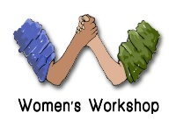Risk Assessment for Working with Young People
Individual’s Name:
Possible Risks | Likelihood | Consequence | Rating | Risk Control
For the individual
For other young people
For staff or vols

Level of Risk
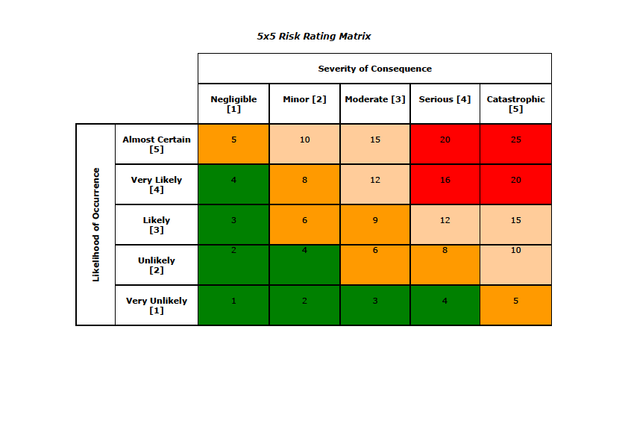

Risk Hierarchy Control

