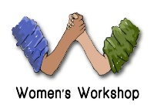Risk Assessment for Working with Young People
Event: Off-site visit
Possible Risks | Likelihood | Consequence | Rating | Risk Control

Level of Risk
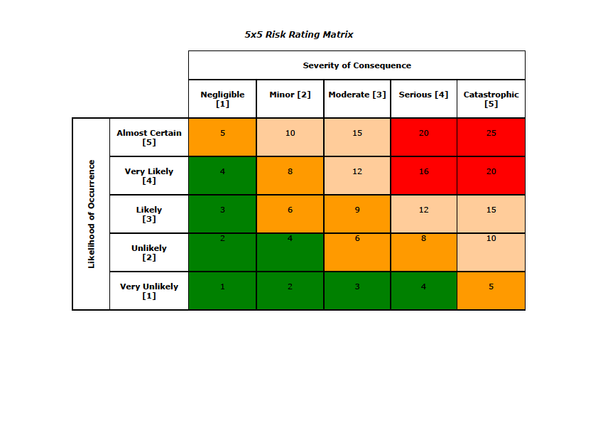

Risk Hierarchy Control

