Reflective Practice in a Youth Work Setting

Unit Workbook

Learner Name:
1.1 Give a definition of reflective practice within the context of youth work.

  - Describe the benefits of reflection in developing youth work practice.

  - Describe the key components of a model of reflective practice.

2.1. - Use a reflective practice model in relation to own youth work.
See evidence number(s) …… for review and evaluation of own youth work and / or reflective journals

2.2. - Use reflective practice to review own strengths and areas for
development. See evidence number …. Skills self-assessment
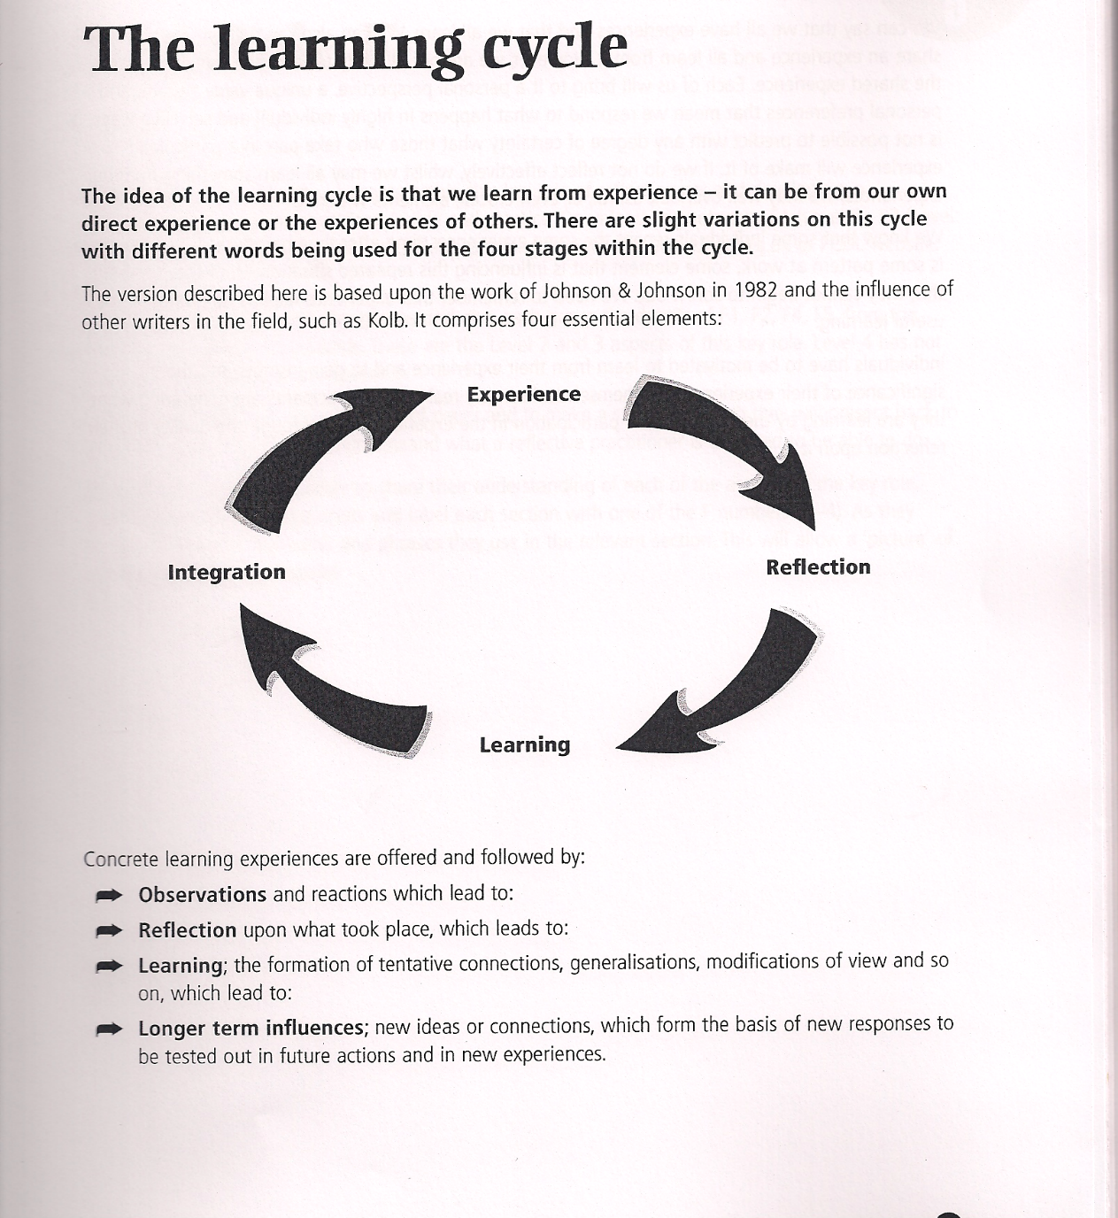
Please give an example of how you have used this reflective process:
2.3. - Create a development plan with organisational objectives to address personal learning and support needs
Development Plan
Pick three areas from your skills assessment that you felt you could improve on..
Skill Area | What do you want to know more about? | What experience would you like to extend? | What do you want more practice in doing?
2.4. - Implement a development plan to address own learning and support needs.
Skill Area | Action Plan for learning and development | By when?

2.5. - Outline how reflective practice relates to organisational performance, appraisal and supervision within own youth work setting.

How do you use the chance to think about your youth work in your job?

