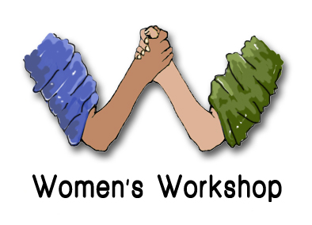

NOCN Level 2 in Youth Work Practice

Unit: Young People’s Development

Workbook

Name of Learner:

1. Understand how young people develop during adolescence.
1.1. Define adolescence.

1.2. Describe theories for adolescent development.

1.3. Outline how adolescent development impacts on young people’s lives.

2. Understand how knowledge of adolescence impacts on youth work.
2.1. Identify how knowledge of adolescent development benefits youth work and young people.

2.2. Describe how changes during adolescence could affect the professional relationship between the youth worker and the young person.

2.3. Outline how changes during adolescence affect young people’s behaviour and lead to stereotypes.

2.4. Describe how to challenge stereotypes impacting on young people

3. Know where young people can get support during adolescence.
3.1. Describe how youth workers can support young people during adolescence.
3.2. Describe helping organisations that can support young people that may face difficulty during adolescence.

