Risk Assessment for Working with Women
Worksheet 17
Choose one of the case studies and complete the risk assessment for them.
Individual’s Name:
Possible Risks | Likelihood | Consequence | Rating | Risk Control
For the individual
For you
For others (e.g. staff, vols, other people using project, family etc)

Level of Risk
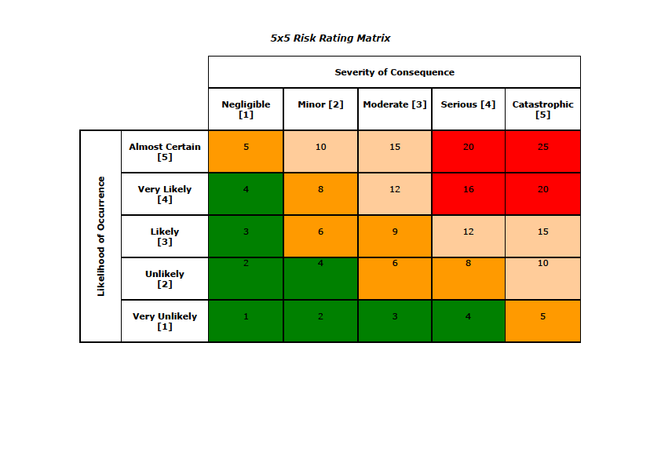

Risk Hierarchy Control

Case Studies:
‘Chai’ 58
Made redundant March 20
Only has access on a phone to online services
Needed to sign up to Universal Credit online in Covid i.e. couldn’t meet inside
English second language
Wanted to continue to be a care worker
Isolated – out of touch with people with shared culture / beliefs
Moved flat Oct 2020
Got Covid Feb 2021
Poor conditions in new care job – 60 hour weeks then laid off

‘Cheryl’ 36
Living rurally, dependent on others for transport
In work provided by family business
Good at maths and accountancy
Living at home without social network except boyfriend
Diagnosed with autism as an adult
Extreme issues with trust because of past experience and prone to anger / meltdowns
Confidence / self-esteem issues

Poppy (21)
Coercive relationship – boyfriend moved in and doesn’t contribute
Poor mental health linked to past trauma
Not managing financially
Money on drugs
Prone to crisis
Can seem to be exploiting the help that’s offered
In one week she asks for: a lift to Newcastle for emergency dental surgery; basic provisions because she misses food bank opening hours; plates and towels: top up for gas which has been cut off; cat food; money.

